University of Pittsburgh at Johnstown
Department of Electrical and Computer Engineering
EE 1195 / COE 1195 Engineering Practice and Professional Development
Monthly Progress Report - 02

Cycle Statistic Tool

Date: March 01, 2021

Submitted By: Jacob Hoffman
Cody Klingler

Instructor: Professor Christopher Gabany
Dr. Maddumage Karunaratne

Project Description:
The Cycle Statistic Tool is a data recording device which will be attached to the frame of a bicycle. In this position, several electronic components may be used to record statistics about a user’s cycling trip. The Cycle Statistic Tool will transmit data to a companion application that is installed on a user’s smartphone. This application will utilize the collected information to provide records of a user’s cycling sessions in the form of graphs and charts that enable the user to improve their cycling skills. An appropriate microcontroller will be used as the primary board to connect all sensors and for operation of the device. A secondary microcontroller will be attached to the pedal shaft to wirelessly relay data from this position to the primary board. Live data will be displayed to the user by a display panel connected to the primary board. The entire device will require a casement which will be modeled and 3D-printed. This casement should be weather-proof and able to connect to the frame/handlebar of a bicycle universally.

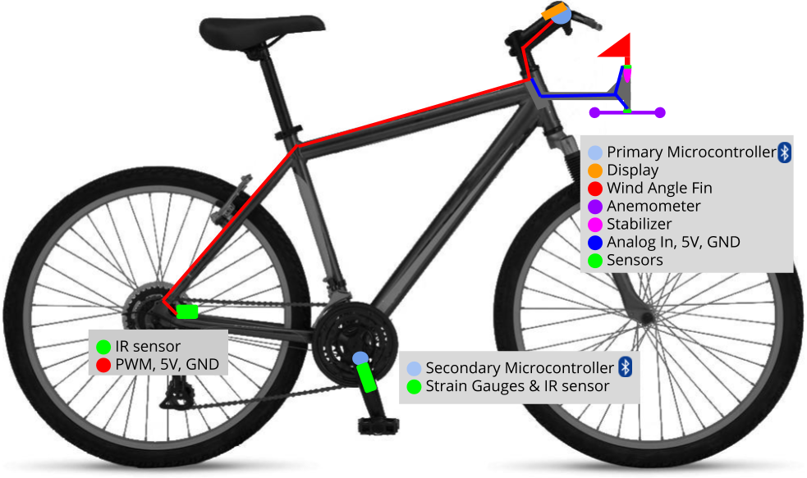
Figure 1: Project Layout

Time Schedule:
Table 1 presents the task division table which provides appropriate start dates, end dates, and estimated time duration for each task to complete the Cycle Statistic Tool within the appropriate time frame. The completed tasks are highlighted green, in progress tasks highlighted yellow, and tasks that have not yet begun highlighted red.

Table 1: Task Division Table
Critical | Task Description | Duration | Start Date | End Date
● | Research Components | 6 hrs | Fri 1/15/21 | Sat 1/16/21
 | Research Bluetooth | 6 hrs | Thu 2/18/21 | Sat 2/20/21
● | Design System | 6 hrs | Mon 1/18/21 | Wed 1/20/21
● | Research Mobile Development | 10 hrs | Fri 1/15/21 | Wed 1/20/21
 | Research Data Analysis | 6 hrs | Wed 3/3/21 | Fri 3/5/21
 | Test Components | 12 hrs | Mon 1/25/21 | Sat 1/30/21
 | Research Data Collection | 8 hrs | Fri 3/12/21 | Mon 3/15/21
 | Test Bluetooth Communication | 8 hrs | Fri 3/5/21 | Mon 3/8/21
 | Design Display UI | 4 hrs | Mon 3/15/21 | Wed 3/17/21
 | Design Wind Sensing Unit | 9 hrs | Sat 2/27/21 | Wed 3/3/21
 | Assemble Wind Sensing Unit | 13 hrs | Fri 3/5/21 | Fri 3/12/21
 | Mount Hardware | 24 hrs | Mon 2/22/21 | Sat 3/6/21
 | Weatherproof | 3 hrs | Mon 3/8/21 | Mon 3/8/21
 | Test Durability | 6 hrs | Wed 3/10/21 | Fri 3/12/21
 | Test Accuracy of Calculations | 13 hrs | Wed 3/17/21 | Wed 3/24/21
● | Design Mobile Application | 12 hrs | Fri 2/12/21 | Wed 2/17/21
● | Code Mobile Application | 78 hrs | Fri 2/19/21 | Sat 4/3/21
 | Code Microcontrollers | 76.5 hrs | Fri 1/29/21 | Sat 3/13/21
● | Debugging | 24 hrs | Sun 4/4/21 | Sat 4/10/21

Green: Completed Tasks, Yellow: Tasks In Progress, Red: Incomplete Tasks
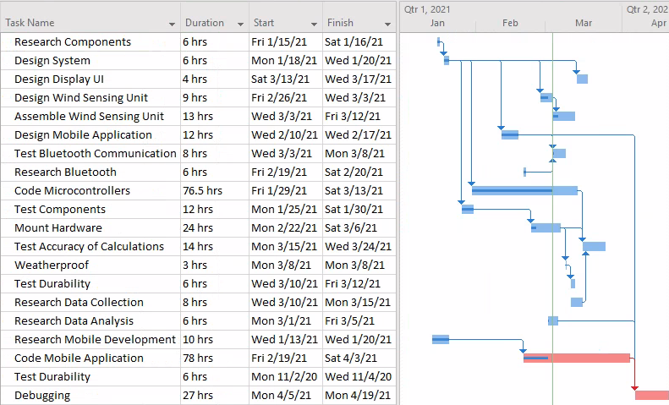
Figure 2: Gantt Chart

The majority of the time spent on the project in February consisted of testing components, programming the microcontrollers, and programming the mobile application. During February the team successfully measured GPS coordinates, elevation, incline angle, angular frequency of the tire and pedal, gear ratio, distance traveled, and instantaneous speed. Work in the coming month should add measurements for torque, power, energy spent, wind speed, and wind angle.

For the mobile application, the project team designed the software requirements specifications document to provide an overall description, explanation of functional requirements (use cases), interface requirements, and other non-functional requirements. After the application was designed through drafting this document, development of the application began. Jacob programmed a database using SQLite for saving all trips and goal profiles onto the device. SQLite will create a table of whatever object you pass into it. The table is then stored locally on the user’s smartphone. Jacob also implemented classes to represent a recorded trip and goal profile. The application can now save trips and goal profiles as needed. Currently, the main pages are being finalized. Also, the project team needs to implement bluetooth connectivity between the hardware and the user’s smartphone with bluetooth.

Table 2: Bill of Materials
Part Number | Product Name | Quantity | Actual Cost | Description
ABX00027 | Arduino Nano 33 IOT | 2 | $18.40 | Microcontrollers with Bluetooth
Adafruit PID: 4224 | Adafruit eInk Breakout Friend with 32KB SRAM | 1 | $8.50 | Memory buffer for eInk display
Adafruit PID: 4262 | 2.9" Flexible Monochrome eInk | 1 | $26.95 | Low power eInk display
C000160 | Grove - Infrared Reflective Sensor V1.2 | 2 | $5.90 | Measures angular frequency
CEA-06-125UT-350 | Micro Measurements Strain Gages | 1 | $29.99 | Measures sheer force
176SF1D-L394 | Honeywell Precision Continuous 10K Potentiometer | 1 | $22.95 | Measures wind angle
PA1010D | Adafruit Mini GPS | 1 | $29.95 | 10Hz GPS module
LP785060 | Lithium Ion Polymer Battery - 3.7v 2500mAh | 1 | $14.95 | Power for Microcontrollers
 | Metal Crank Arm | 1 | $13.63
 | Misc |  | $87.69 | Jumpers, Headers, Solder, additional strain gages, glue, catalyst, etc.
 | Shipping |  | $35.99
 |  | TOTAL | $294.90

All major components have been acquired for the assembly of the Cycle Statistic Tool, except an additional lithium ion battery to power the secondary microcontroller while attached to the bicycle. However, a single battery will allow for the development and testing of the project until the project team is ready to mount the hardware onto the bicycle. Some miscellaneous purchases have yet to be made such as mounting brackets for the hardware and materials for constructing the stabilizer component of the wind angle fin.

Unexpected Items:
Cody had to order a metal crank arm and some crank arm removal tools. This was necessary because the crank arm on the bicycle was plastic and the strain gauges are intended to be mounted on metal. Cody also had difficulty attaching strain gauges to the crank arm. After damaging all 5, another set of them had to be ordered. Additionally, a 2.4Ghz antenna snapped off of one of the arduinos and had to be resoldered. The only unexpected issue that has yet to be resolved is a transmission failure of data buffers from Arduino to Arduino via Bluetooth Low Energy. At this point, it is unclear why this issue is occurring.
For the application, Jacob had some issues planning how to properly save all the user data to the device. A solution was found with SQLite which helped by providing a cleaner implementation and table format. This also gives easy access to data objects’ parameters for use cases requiring event handlers or modifiers.

Customer (Functional) Requirements and Engineering Specifications Targets:
The Engineering Specifications Table is presented in Table 3. There were no changes made to the table. Apart from cost of materials, the engineering specifications have not been evaluated yet. Most of these will be tested during the tasks “Testing Accuracy of Calculations” and “Testing Durability”. The total cost of materials so far is $294.90 and a breakdown of this figure can be seen in Table 2. This is well below our target cost of $500. Although there are still a few materials that need to be acquired, the project team believes the total cost of materials will end up below our target.
Table 3: Engineering Specifications Table
Engineering Specification | Unit | Direction | Target | Threshold
Size  Ease of use | m³ | ▼ | .2 | .5
Overall Accuracy of Sensors  Accuracy of measurements  Price  Battery life | % | ▲ | 90 | 80
Accuracy of Power Metric  Accuracy of measurements  Price  Battery life | % | ▲ | 90 | 75
Accuracy of Speed Metric  Accuracy of measurements  Price  Battery life | % | ▲ | 95 | 85
Cost of Materials  Accuracy of Measurements  Price  Battery life  Durability | $ | ▼ | 500 | 700
Weatherproof  Price  Weatherproof  Durability | IP | ▲ | 23 | 54
Battery Life  Price  Battery life | hr | ▲ | 12 | 3
Lifespan  Weatherproof  Durability | mo | ▲ | 24 | 12
Time to View Metrics in App  Statistic utilities in app | s | ▼ | 2 | 6
Setup Steps Before Use  Attaches universally  Ease of use  Ease of setup |  | ▼ | 3 | 6
Steps to Attach to Bike  Attaches universally  Ease of use  Ease of setup |  | ▼ | 10 | 20

